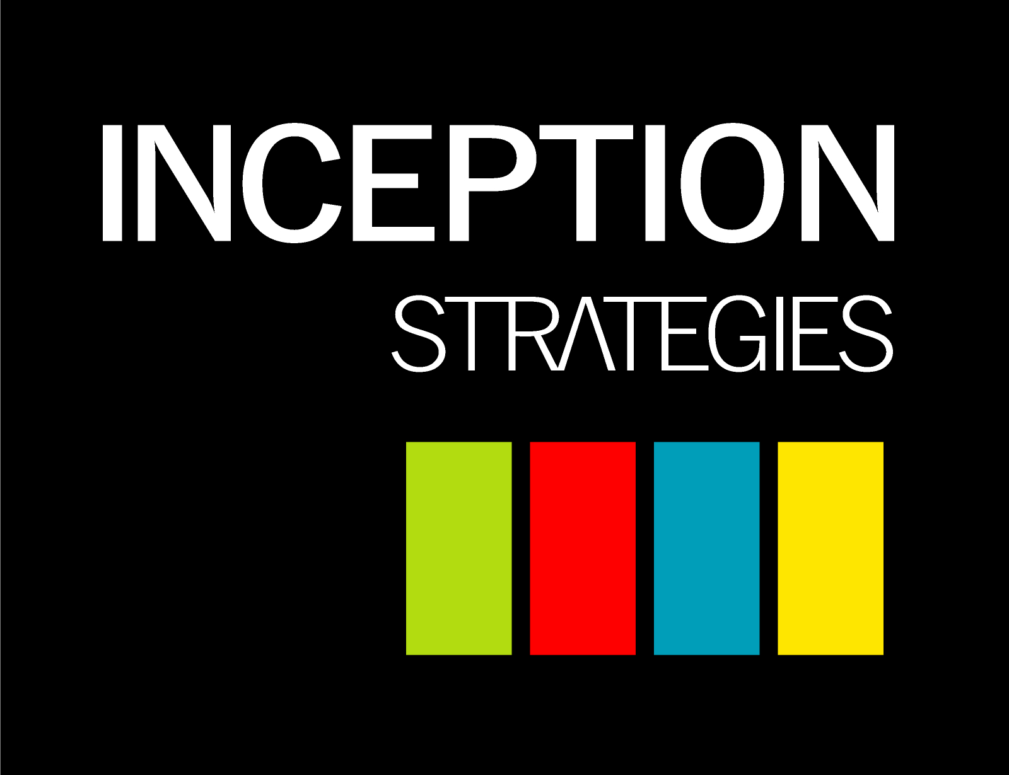

19th August 2015

19Sheep meeting

In attendance: Gareth McFarlane, Tommy (Zhongyi Tang), Chris George, Emile Khreich,

Frank (Kong Ming Leung)

Apols: Deniz,Tony Dimrajian and Nick

Action Items

Damian - Content, front end and e commerce

Gareth - Facebook Google and Linked logins, withings API

Chris - Dream Analyser

Tommy - CSS and Front End

Emile - database and login profile

Tony and Nick - video

Deniz - Data Sets

Frank - Emotion capture and chart overlay

AGENDA:

1. Strategic Discussion - from Desk and Mob App to Desk and Mobile web, from API x 4 to API x 1, scoring with the spectrum from Dream Input (Individual) to conservative Corporate reporting (Enterprise). Inclusion / Maintenance of activity data but not the focus. Avoidance of competition which breaks down personal worth / expense of someone else.

2. Progress - Case Study

Article

lifedojo.com

3. Progress - Site Design - view PPT

4. Work allocation

5. Discussion about video display as youtube video tree. Important for youtube video’s to be unlisted.

6. Next meeting is Skype call 9.30am Wed 26th August